1. Project Setup and Data Loading Task: Load the dataset and perform initial setup. Questions:
libraries are required for this project, and why are they useful in data analysis?
Required Libraries and Their Purpose
pandas For loading, cleaning, and exploring tabular data (e.g., CSV files).
numpy For numerical operations, averages, and handling missing data efficiently.
matplotlib.pyplot For static data visualization (line plots, bar charts, histograms).
seaborn For advanced, beautiful visualizations with statistical insights (boxplots, heatmaps, etc.).
Load the dataset. What is the shape of the dataset? What does each row and column represent?
df.shape → returns something like (10178, 12). This means there are 10178 movies and 12 columns (features).Each row represents one movie record.Each column represents an attribute (e.g., name, genre, score, revenue, budget_x, etc.).

2. Data Overview and Basic Exploration Task: Explore the structure and composition of the dataset. Questions:
Use .info() to understand the data types and missing values. What potential issues can you spot?
This will show:Column names,Data types (int64, float64, object),Number of non-null values (to identify missing data)

Describe the main characteristics of each column using .describe(). What can you infer from the mean, median, and distribution of numerical columns?
This gives:
For numeric columns (score, budget_x, revenue):mean, std, min, (median),max
Mean: Shows the average value (affected by outliers),Median: Middle value (better for skewed data),Mode: Most frequent value (useful for categorical/numeric trends).

3. Data Cleaning Task: Address missing values, data types, and outliers. Questions:
Which columns contain missing values? How would you handle them?
df.isnull().sum() return null values of all columns
1. Genre Column (Categorical)
Since genre is a categorical column, missing values usually mean the genre wasn’t recorded.
You can fill these with a default value like "Unknown" or "Other" to keep the data consistent.
The crew column often contains names of directors, writers, etc.
Fill with "Not Specified"
Are there any columns where data types need conversion (e.g., date, ratings)? Explain your decision.
date_x Column (Date Type),The date_x column likely stores release dates as strings (object type).Convert it to a datetime format for accurate time-based analysis (like grouping by year or decade).
df['date_x'] = pd.to_datetime(df['date_x'], errors='coerce')
4. Univariate Analysis: Explore each column individually. Task: Perform univariate analysis on numerical and categorical variables. Questions:
What is the distribution of movie runtimes? Plot a histogram and describe its shape.
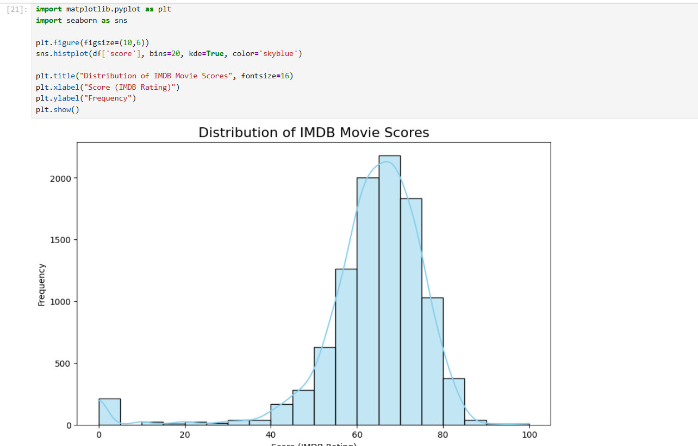
What are the most common genres in the dataset? Use a bar chart to show their distribution.
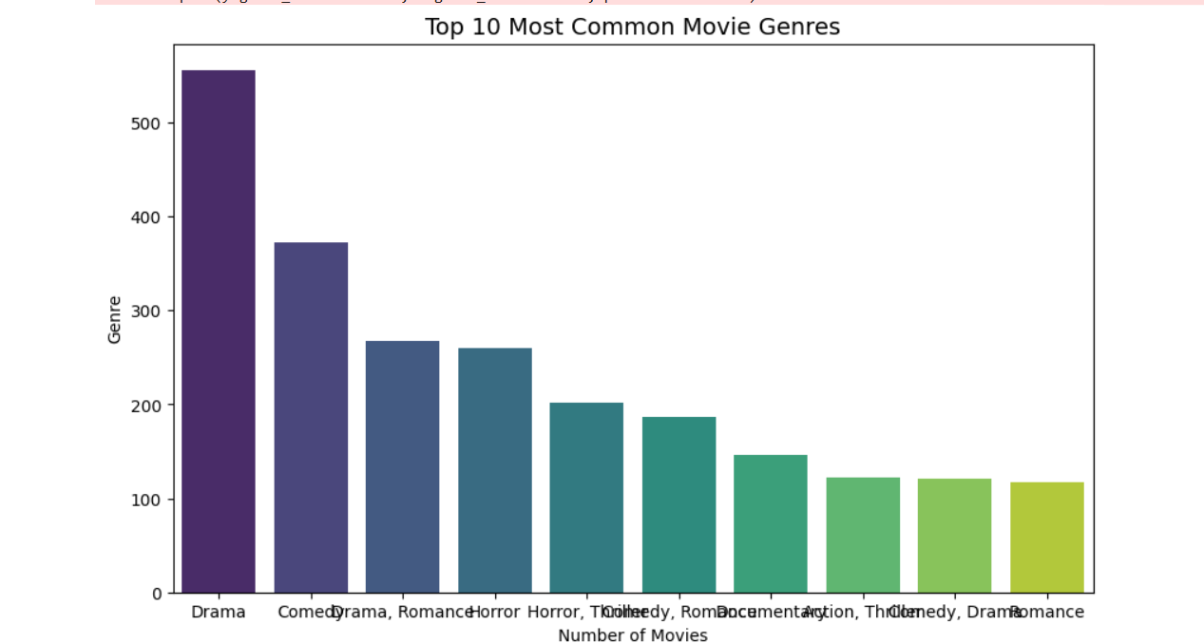

5. Bivariate Analysis: Explore relationships between two variables. Task: Use scatter plots, box plots, and correlation analysis. Questions:
How do ratings vary by genre? Use a boxplot to visualize the differences in ratings across genres.
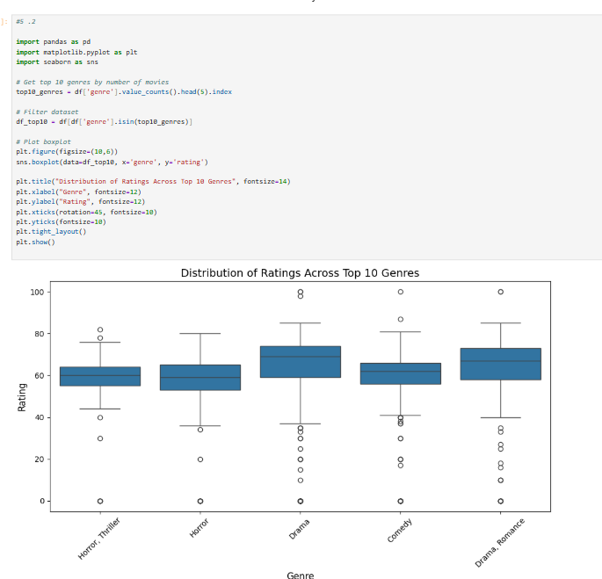
Is there a correlation between the number of votes a budget and revenue? Create a scatter plot and calculate the correlation coefficient. What can you conclude?

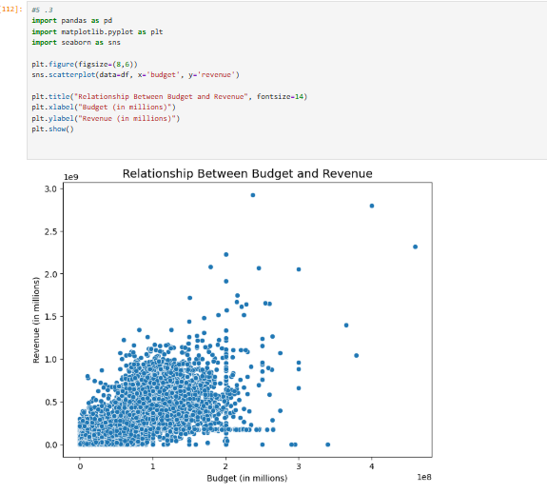

6. Genre-Specific Analysis Task: Delve deeper into the genre of movies. Questions:
Which genre has the highest average rating? Calculate the average rating for each genre and plot the results.
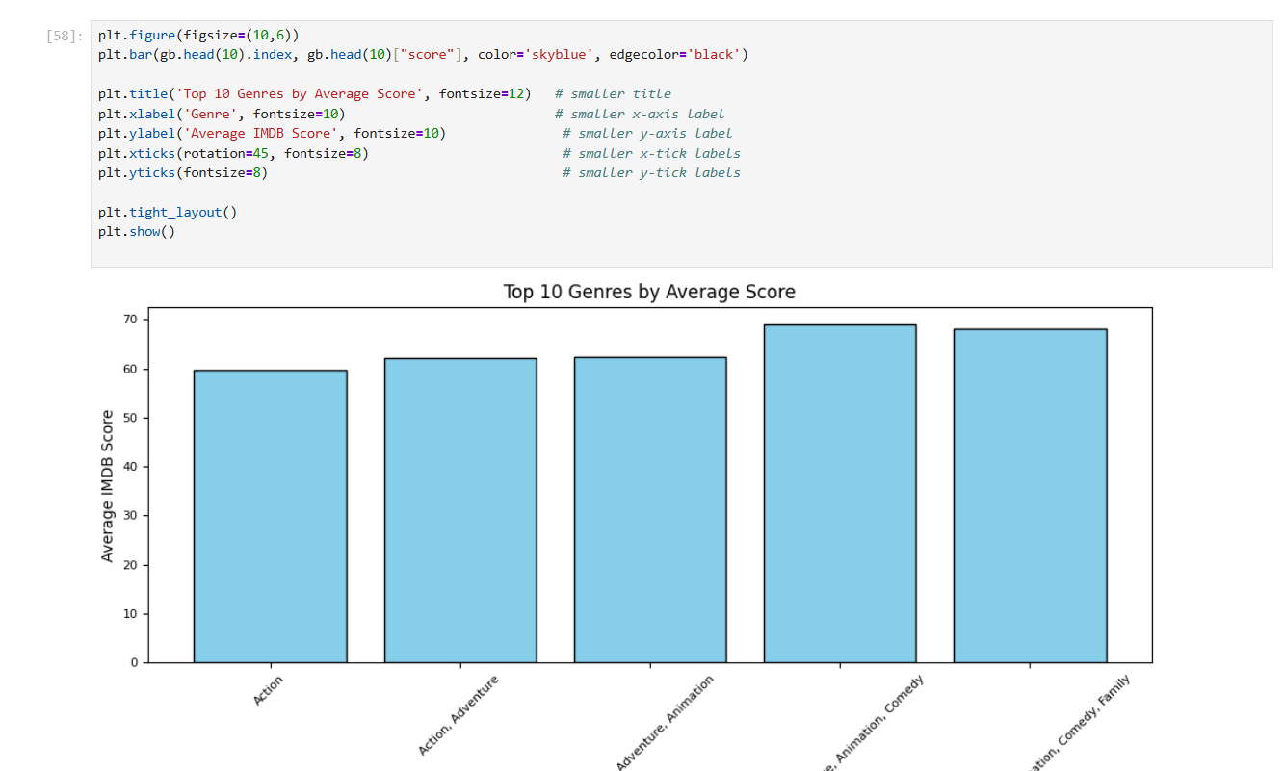
How does the popularity of genres vary over time? Plot the number of movies released per genre each year.
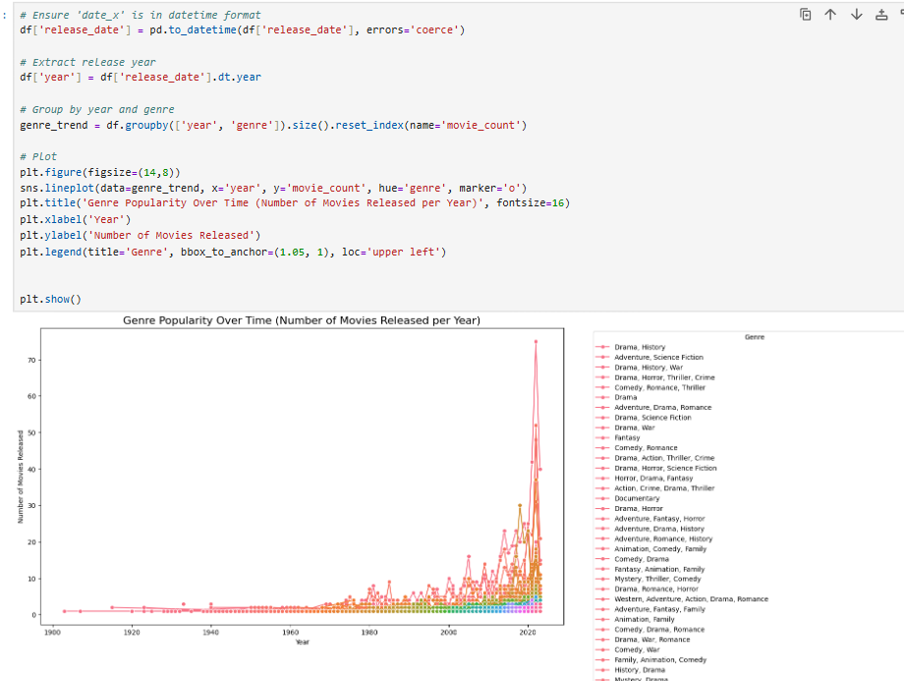

7. Year and Trend Analysis Task: Analyze trends over time. Questions:
How has the average movie rating changed over the years? Plot the average rating for each year.
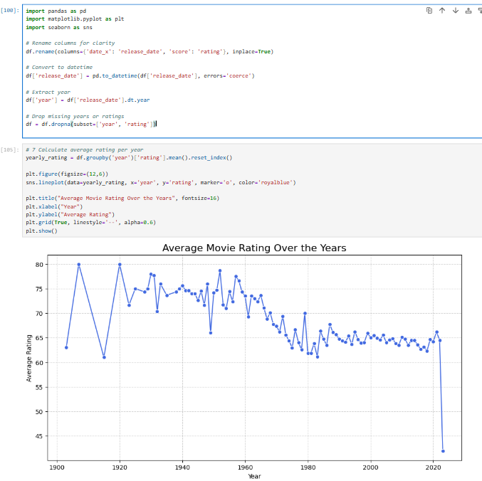

Which years had the highest and lowest number of movie releases? Plot the number of movies released each year.
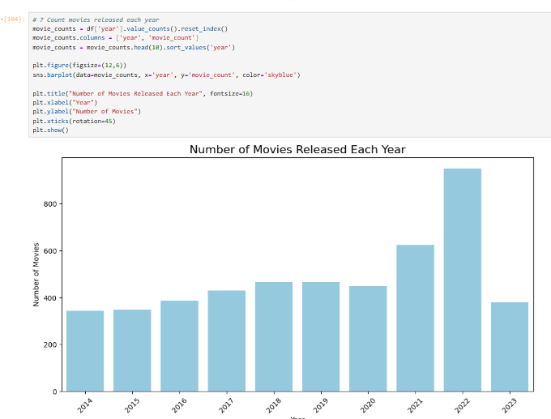

8. Multivariate Analysis: Analyze multiple variables together. Task: Combine insights from multiple columns to explore complex relationships. Questions:

Which genres are most popular in each decade? Create a bar plot showing the most frequent genres by decade.
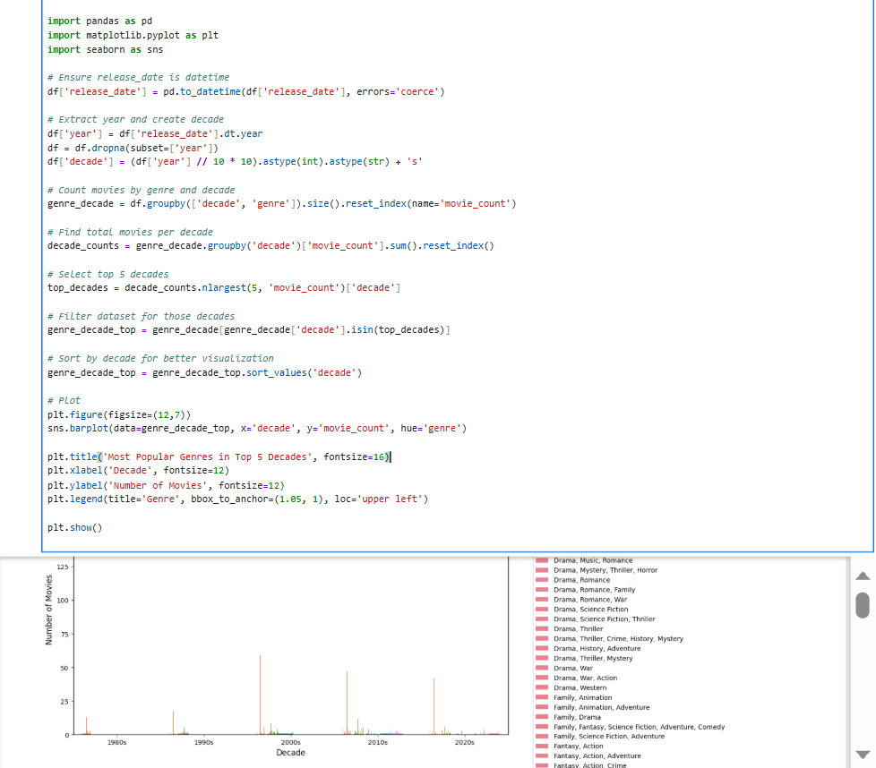Plot a
heatmap or pairplot to examine relation ships between budget, revenue, scores.
